**MOTOROID**

User Manual

To

MD Shohel Arman

Lecturer

Department of Software Engineering

Daffodil International University

By

SM Rabby Hasan

ID: 171-35-1910

Department of Software Engineering

Daffodil International University

INTRODUCTION

This document is an example of a user-manual for an Online Motor Rent System. The audience for the document includes both Rider and Renter. The assumption was that the users are not very technically savvy, so both the application and the user manual had to be intuitive and easy to use.

I have included the original Table of Contents to illustrate how much detail the manual provided. Following that is one section of the manual, so the reader understands my writing style. All references to any proprietary information has been removed.

This is the first page of my website which contains ‘Home’, ‘Rider’ and ‘Renter’ options.

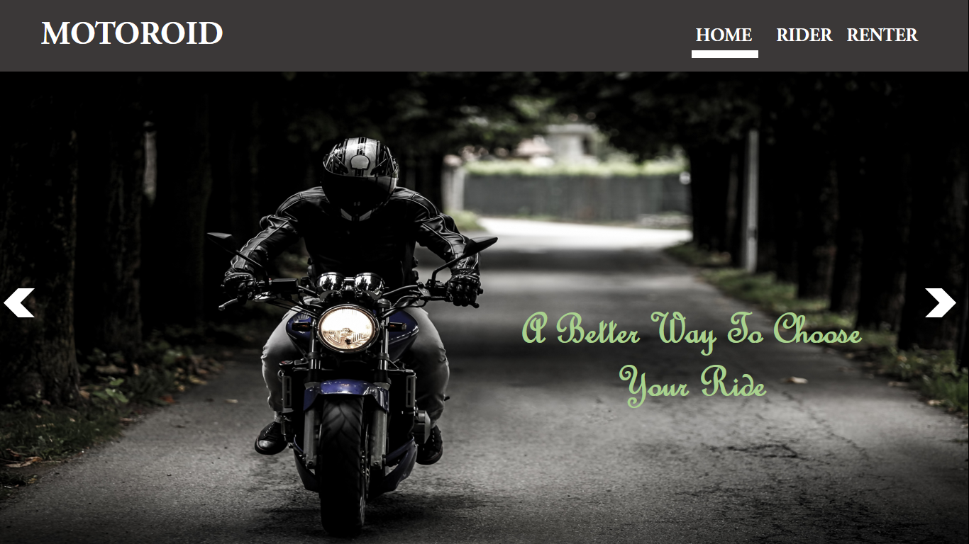

This showing that it is in the Home page.

Now the rider have click on the Rider button.



Now the below page will appear.

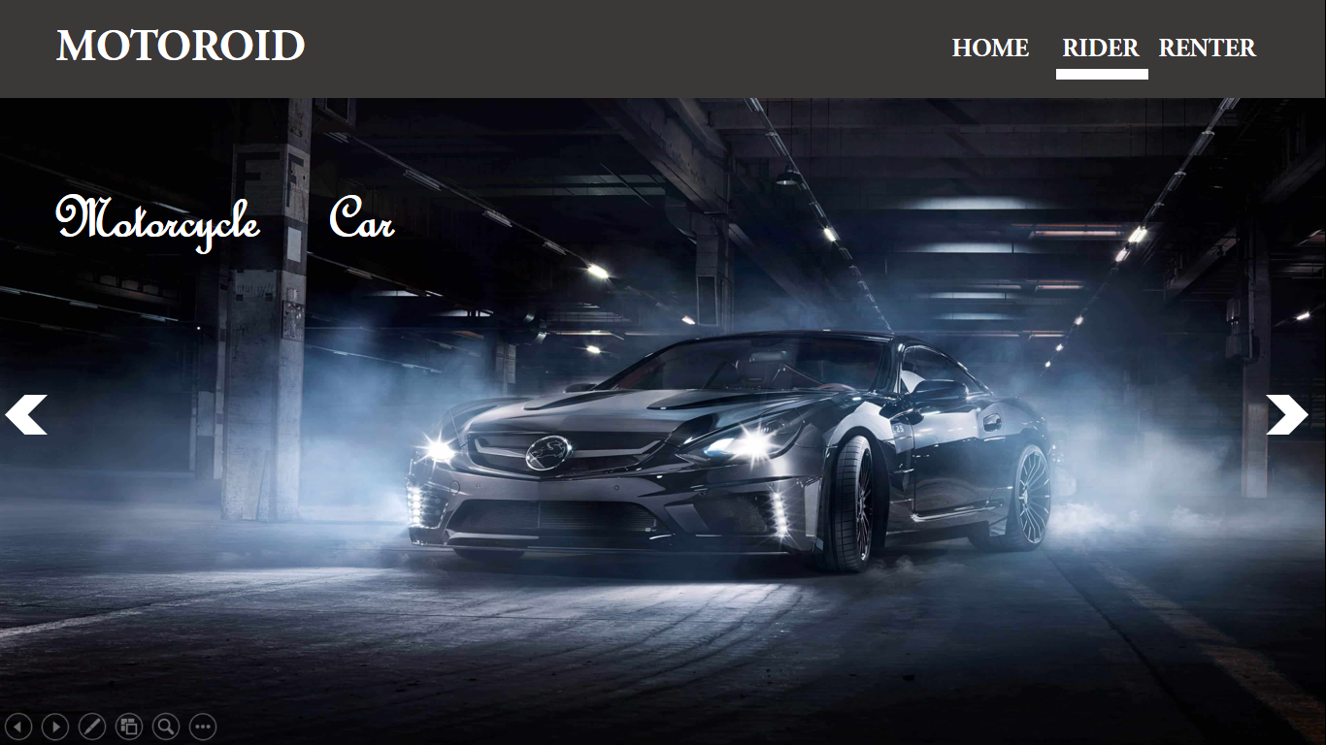

In this page the user can see two option. One is ‘Motorcycle’.

Now if the user click on ‘Motorcycle’ option. Bellow page will appear.

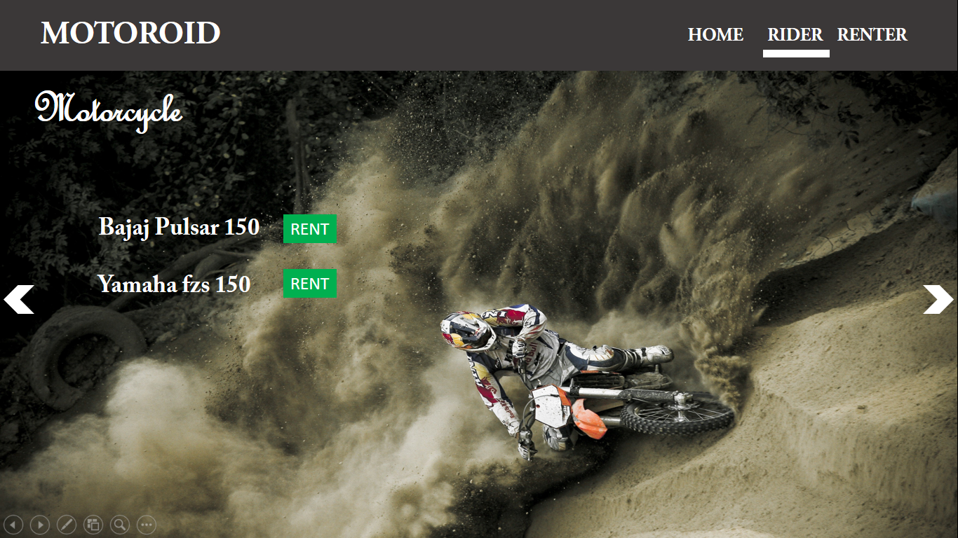

This page showing the available vehicles and ‘Rent’ option.

Now If the user press ‘Rent’ this page will appear.

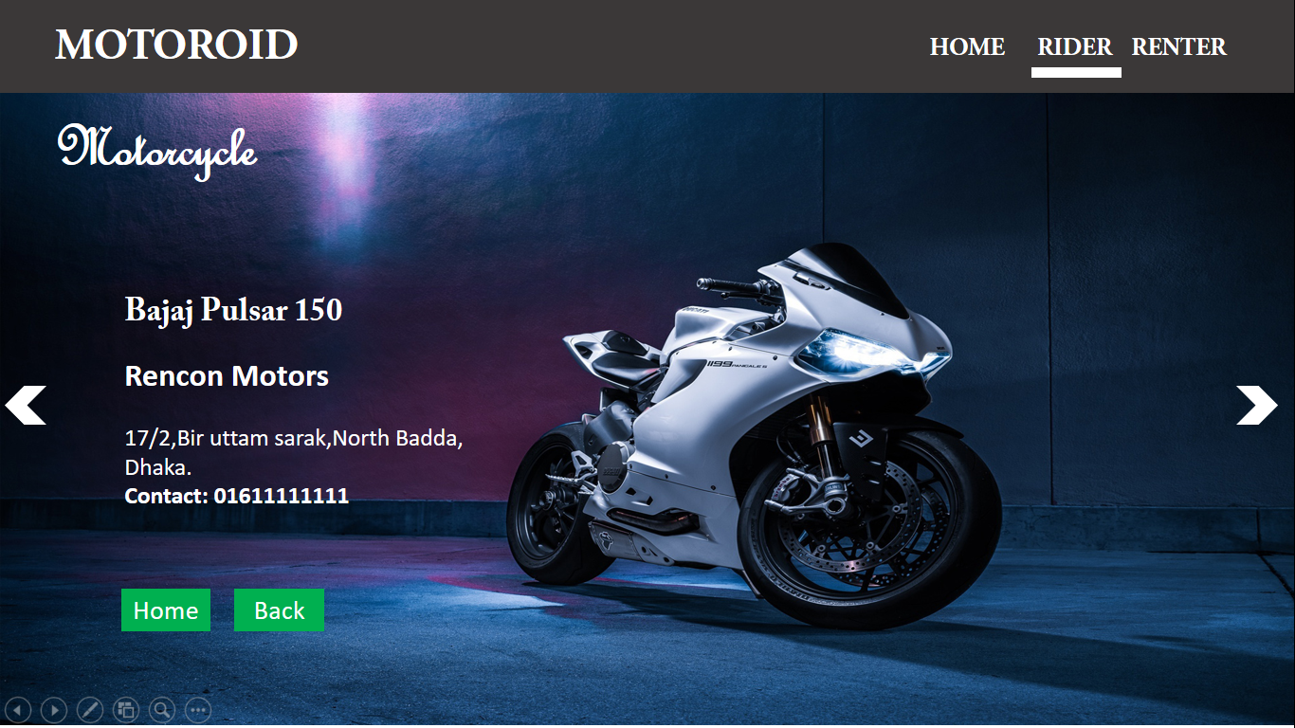

In here the user can see the provider name, address and contact number. If the user want to rent has to call and can book. In this page also has two option ‘Home’ and ‘Back’.

This option is for Going back to Home page.

This option is going back to previous page.

Same For the “Car’” option.

This page is for Renter.

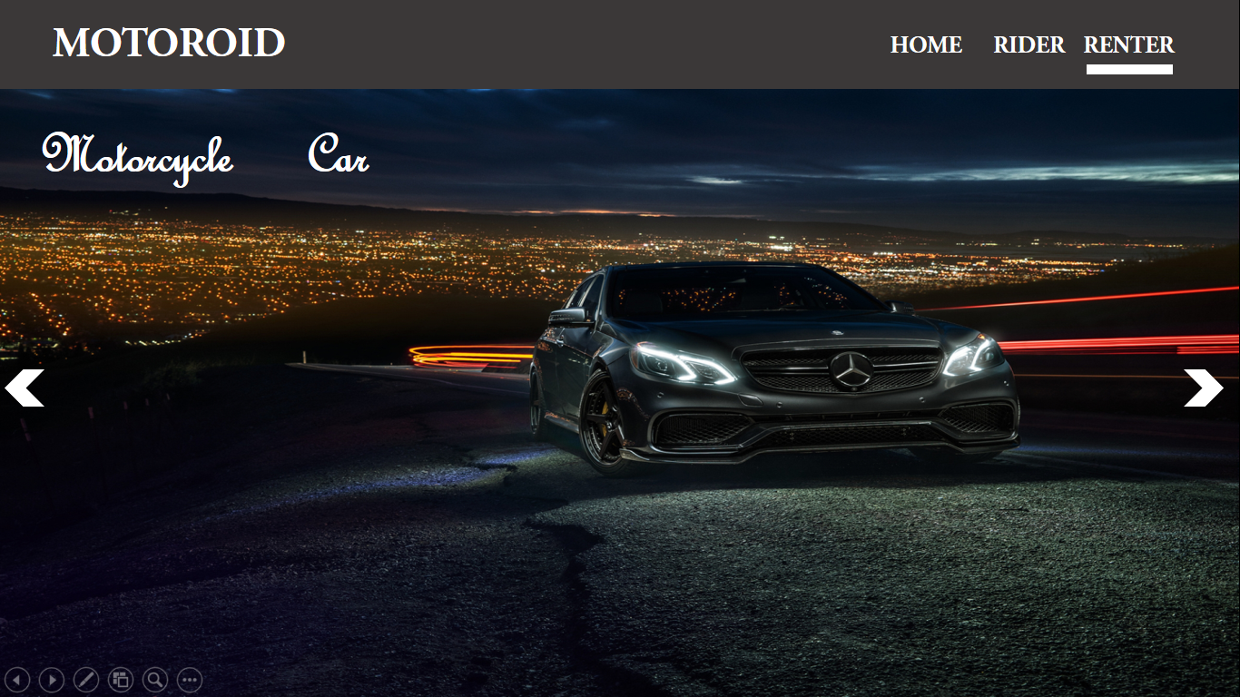

If the Renter wants to add a motorcycle has to click on motorcycle option

And This page will appear.

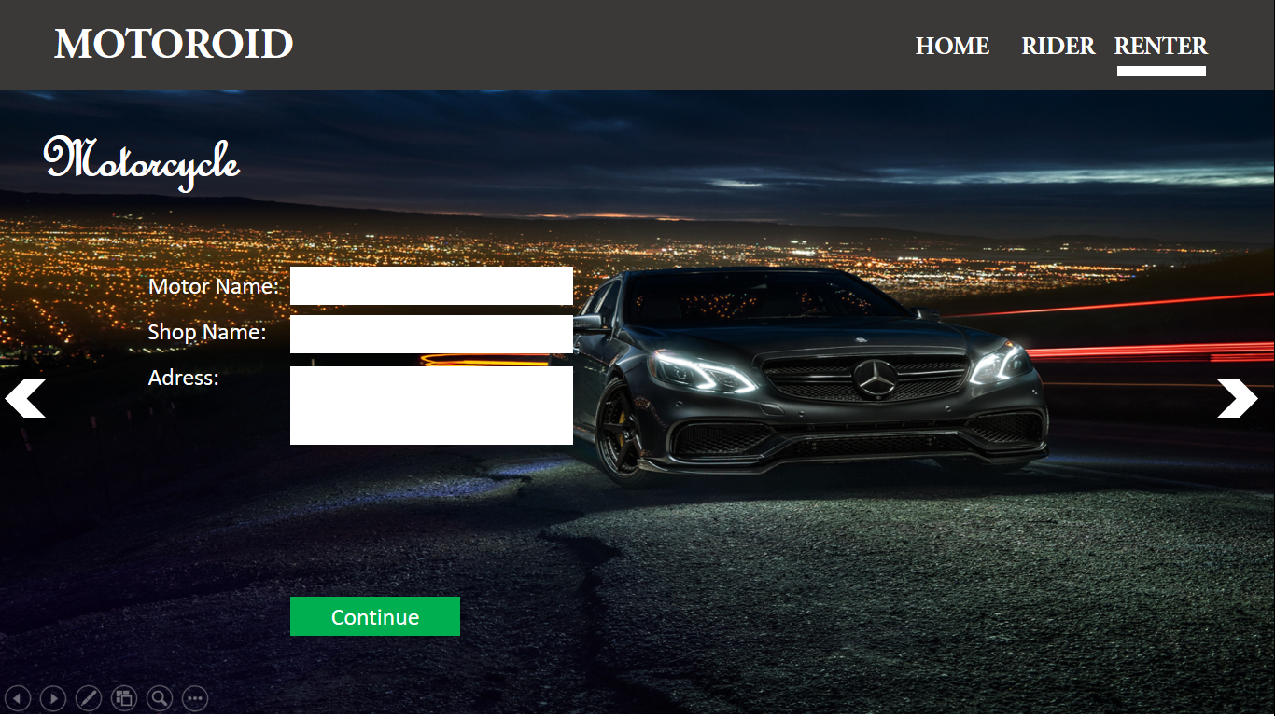

In here the renter has to enter all the information about the shop and contact number and click on ‘Continue’.